Function Reference id: TT1.2_ withtwoitemHH1

Declaration id - 19GB4TQ2T66UNFGVA5

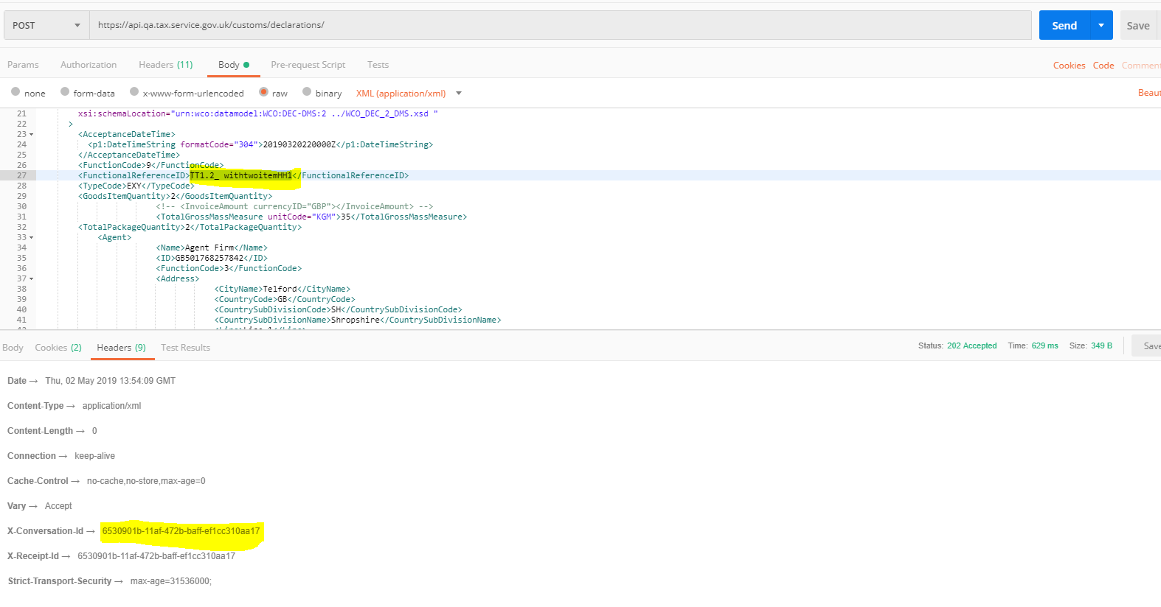

Kibana logs – Function code-09

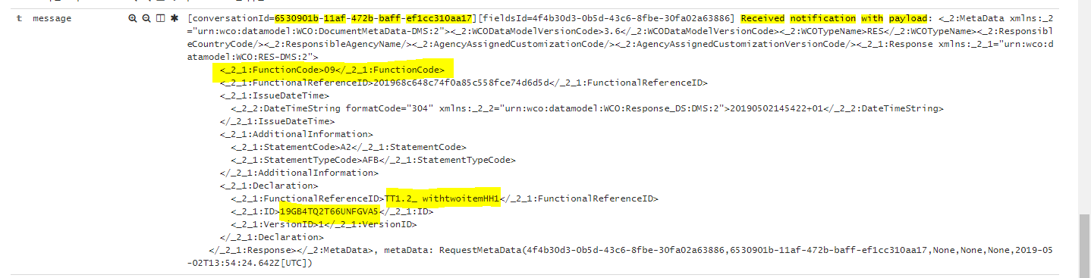

Function code -01

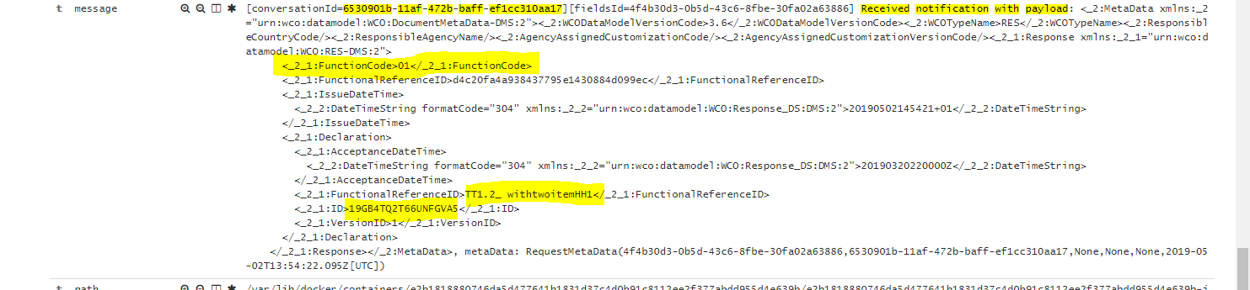

DMS Overview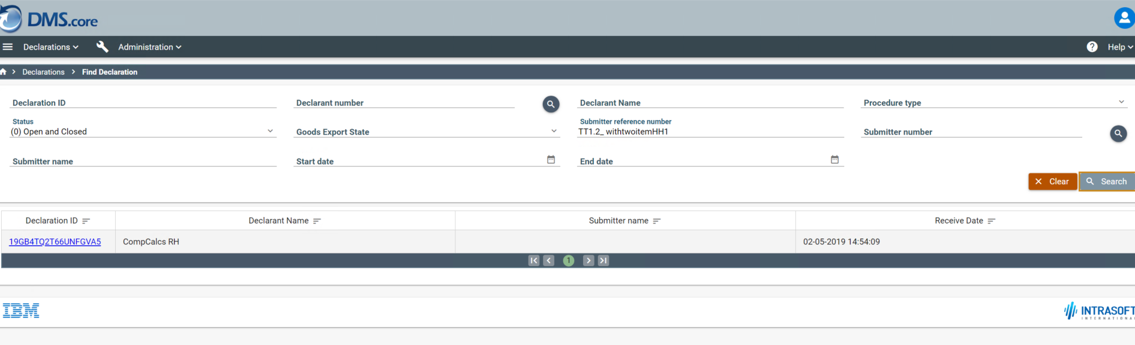

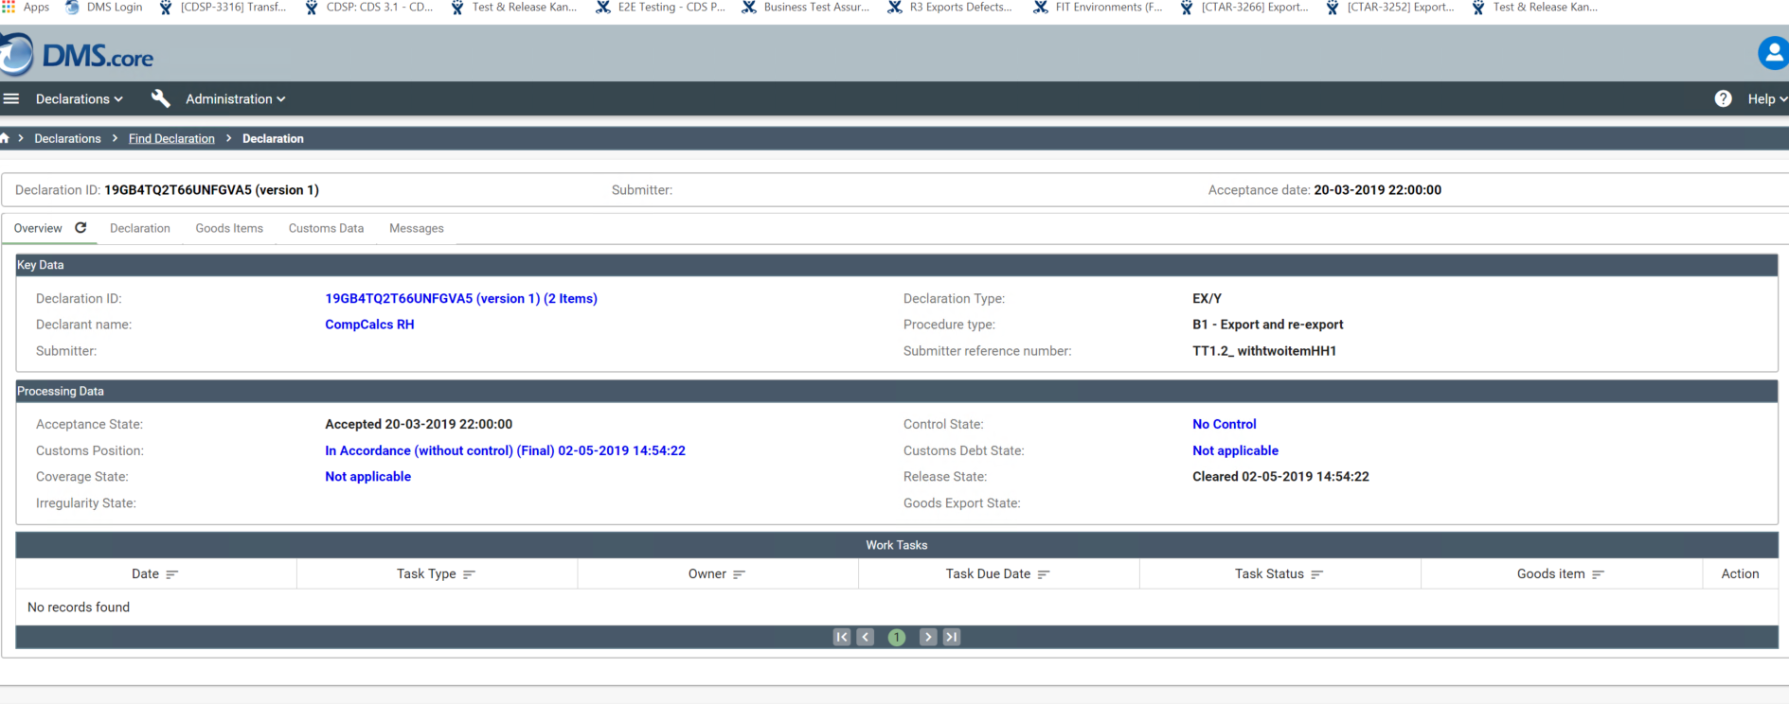

Trader Notifications – DMS ACC

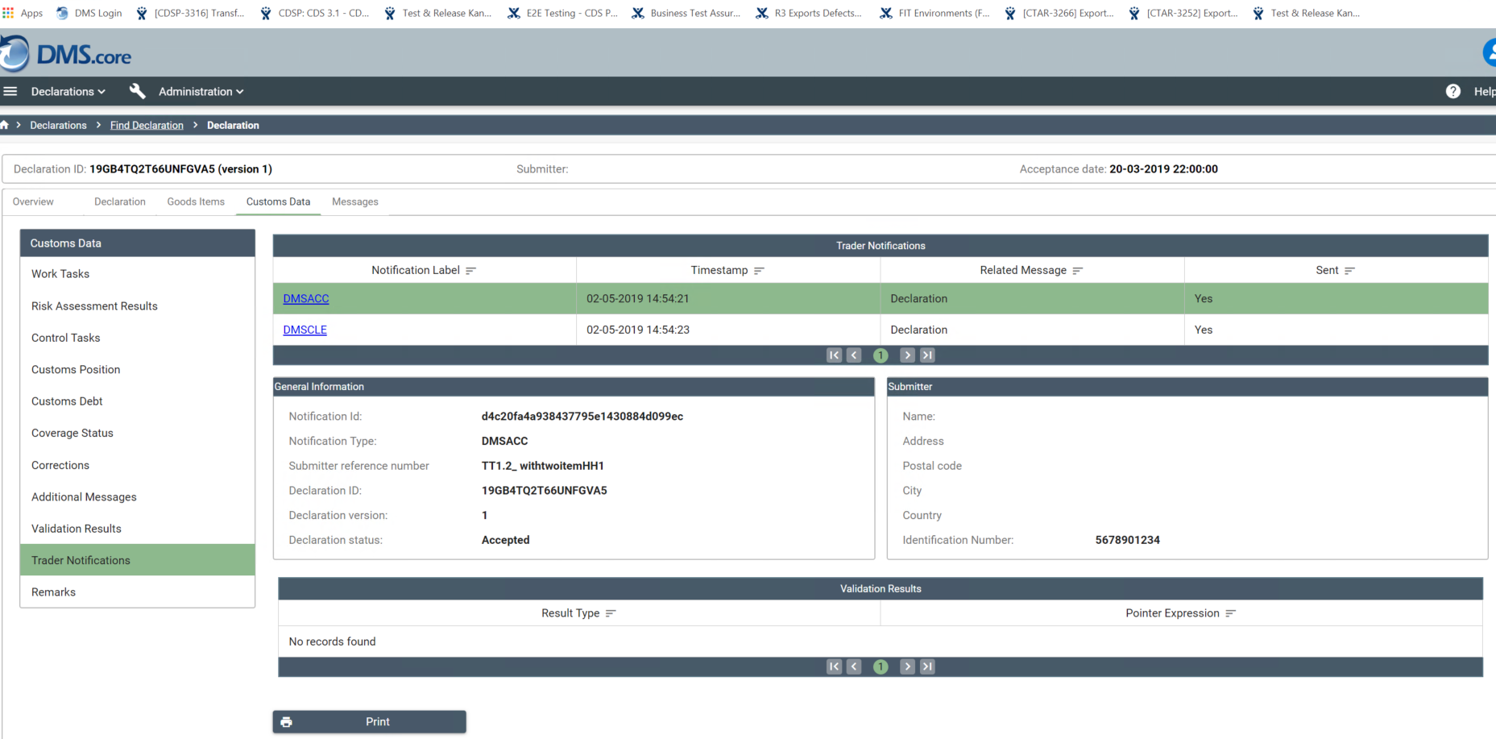 Trader Notifications – DMS ACC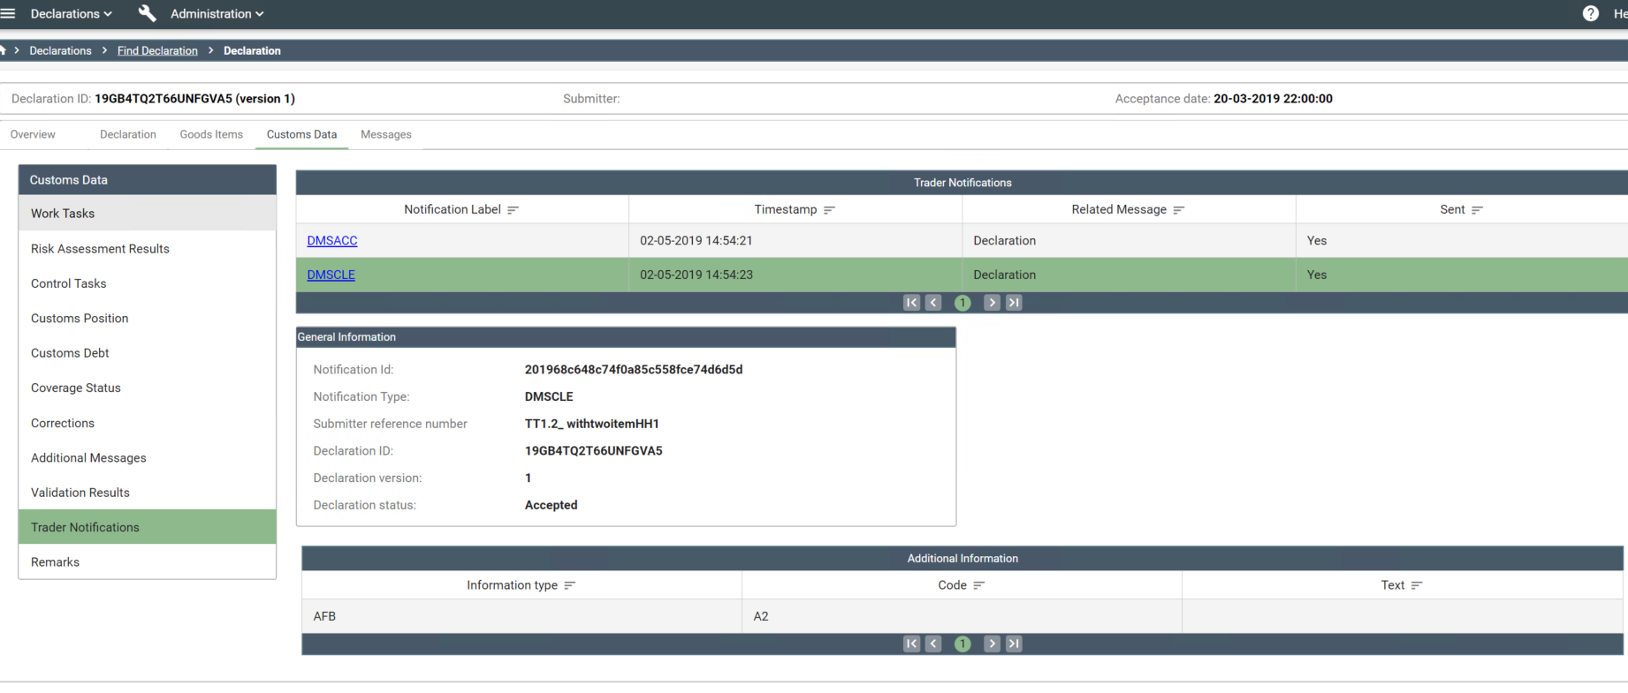

DMS Messages

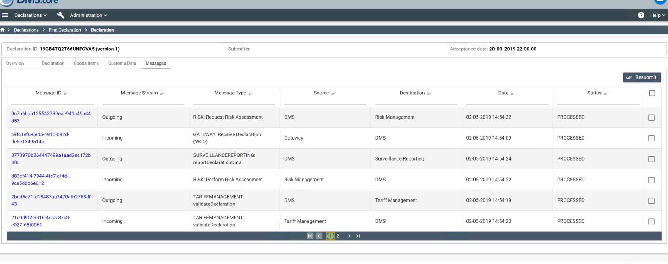

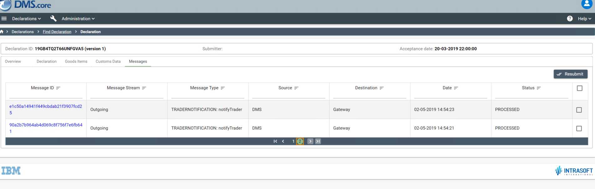

DMSACC – Function code 01

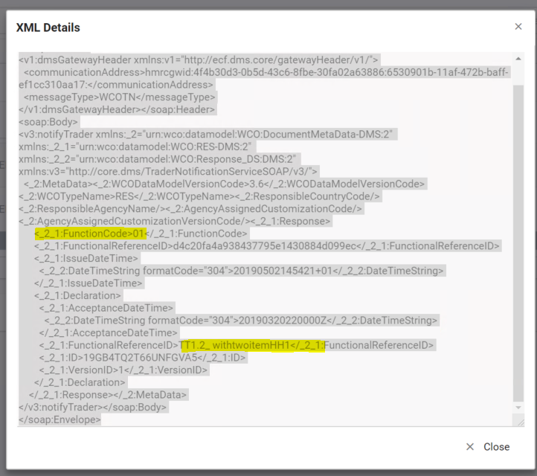

DMSCLE - – Function code 09